**Datamatics Hackathon – IIT Bombay Techfest’24**

**ABSTRACT:**

With the increasing demand for automation in business processes, leveraging tools like Datamatics TruBot and TruCap+ can significantly reduce manual tasks, improve accuracy, and increase efficiency. This project aims to develop an automation solution for customer feedback email analysis, utilizing the Gmail API for fetching feedback emails, Google Cloud Natural Language API for sentiment analysis, and Google Forms for data submission. The automation will classify feedback as positive, negative, or neutral, extract key details such as customer name, order ID, and feedback category, and send summary notifications to the customer service team. By streamlining the processing of customer feedback, the solution will enhance customer service operations and provide actionable insights for business improvement.

**ROADMAP:**

The roadmap for the project is outlined as follows:

### 1. Project Planning

Define project objectives, scope, and requirements. Identify key stakeholders and outline the expected outcomes.

### 2. Environment Setup

Set up the development environment, including installing necessary libraries and configuring Google Cloud services.

### 3. OAuth 2.0 Authentication

Implement OAuth 2.0 authentication to securely access the Gmail API and generate the token.json file.

### 4. Fetch Emails

Develop functionality to connect to the Gmail API and fetch customer feedback emails.

### 5. Sentiment Analysis

Integrate Google Cloud Natural Language API to analyze the sentiment of feedback emails.

### 6. Data Extraction

Implement logic to extract key details (customer name, order ID, feedback category) from email content.

### 7. Google Forms Integration

Create a Google Form and develop functionality to submit extracted data into the form.

### 8. Summary Email Notification

Implement email notification system to send summaries of feedback analysis to the customer service team.

### 9. Testing

Conduct thorough testing of the entire automation process to ensure functionality and accuracy.

### 10. Deployment

Deploy the solution in a production environment and provide training to the customer service team.

### 11. Evaluation and Feedback

Gather feedback from users and stakeholders for further improvements and updates.

**SEQUENCE DIAGRAM:**

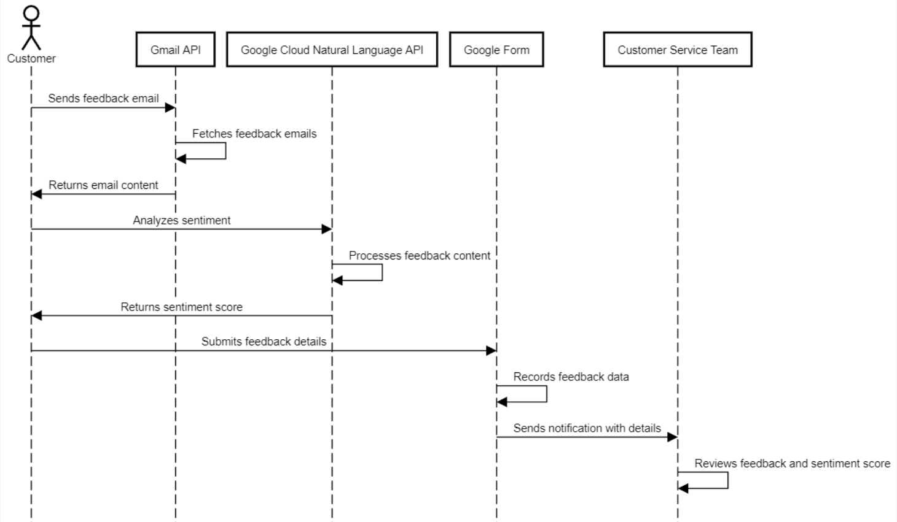

**Team ID:** Data-230286

**Team Members:** Karan Singh (Team Leader)

**Team Leader Email ID:** [karanns.aero19@gmail.com](mailto:karanns.aero19@gmail.com)

**Challenge 1: Customer Email Feedback Analysis Automation**